Sunzi’s Remainder Theorem

Most people refer to our next topic as The Chinese Remainder Theorem. This is meant to honour the mathematician who first discovered it. However we don’t say “The English Theory of Gravity” or the “Greek Triangle Theorem” etc. - we call them Newton’s Theory of Gravity and Pythagoras’s Theorem. The Chinese Remainder Theorem was discovered by Sunzi, a mathematician of the third century AD, and I think it should be properly named after him. But I don’t think I have much chance of changing the world so if you want to be like everyone else, go ahead and call it the Chinese Remainder Theorem.

Anyway, here’s the situation. Suppose we have two pieces of information about 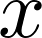:

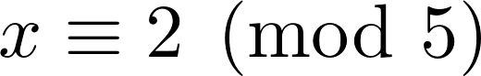 (ie 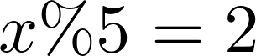) (1)
and
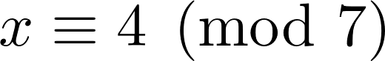 (ie 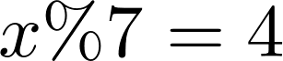) (2)

We want to find all values of (if any!) that satisfy these requirements.

We’ll work through the solution, then discuss the general case, then do a few more examples.

From (1), we know 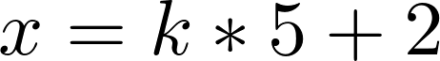 for some value of 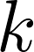

From (2), we know 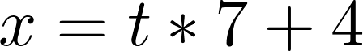 for some value of

If we substitute (1) into (2) we get
which simplifies to
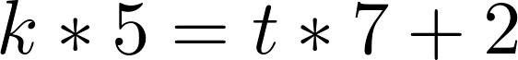 ie 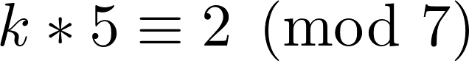

If we (temporarily) drop into 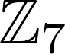 we can write this last equation as
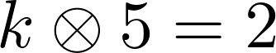

Now 5 and 7 are relatively prime so we know 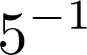 exists in … in fact, 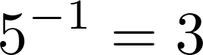 in (How did I know that? I just worked it out.)

So we can write
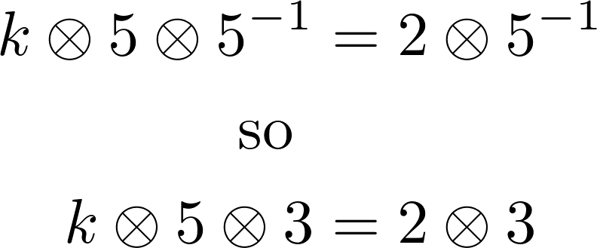
or
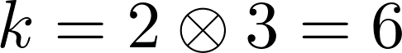

But this is only part of the story … because we need to step back out of to the set of all integers.

We now know we need to satisfy and that 6 is one solution for k … and that means 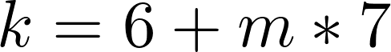 is also a solution for , for any integer 

Thus we can state
where is any integer (3)

And now at last we can solve for 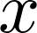, because we started with

Substituting our equation for k into this gives

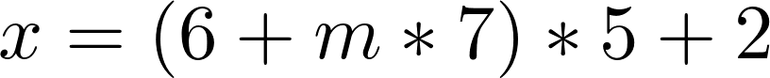 where is any integer

which simplifies to
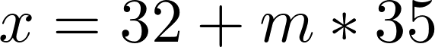 where is any integer

and this is our solution. You should check to make sure that this set of values satisfies the two requirements on . You should also work out an proof that any value of x that does not satisfy this formula is not a solution to the original problem.

Think about how you would do this before going on the the next page!

Here’s one way to construct such a proof:

Let be any solution to the original problem which cannot be expressed as for any integer (Yes, we are going for Proof by Contradiction)

Let 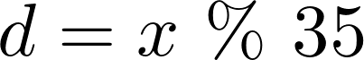 i.e. 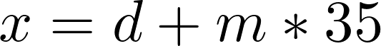 for some , and 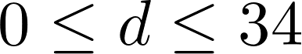
We know 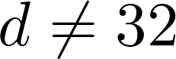

We also know 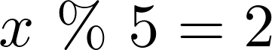
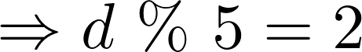

We also know 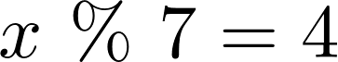
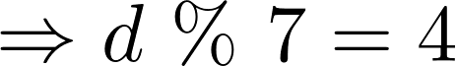
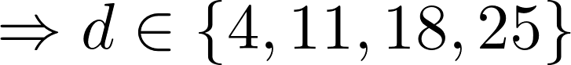

CONTRADICTION! 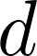 cannot be in two sets that do not intersect.

Therefore no such exists.

Let’s review and generalize the procedure we used to find the solution to that problem. Our goal is to find all values of that satisfy these equivalences:

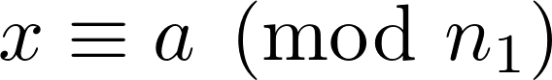
and
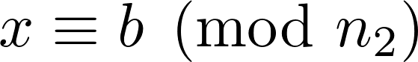 (WLOG assume 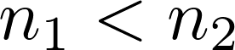)

which we rewrite as 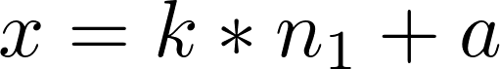 and
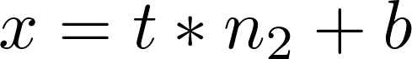

We combine these to get
ie

Our short-term goal is to get a formula for 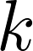, and then use that to get a formula for .

Now we drop into 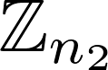 - all arithmetic is now done with 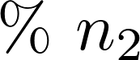 attached so the 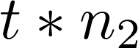 term just vanishes. We get
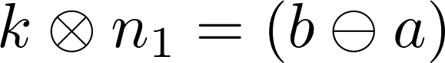 in

We multiply both sides of this by 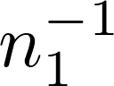

(WAIT A SECOND! How do we know 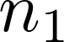 is invertible in ? Well, we just have to make sure it is … and that means we have to specify that and 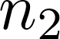 are relatively prime. By “good fortune” our example used 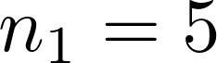 and 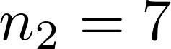, which satisfy this requirement.)

Ok, so let’s assume and are relatively prime, so we can keep going. As I was saying, we multiply both sides by , giving
in
which gives
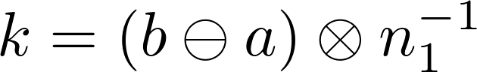 in

Here 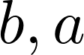 and are known values so we can work out the value of 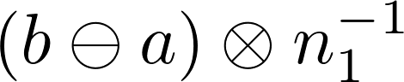 … call it 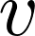 … so we can write
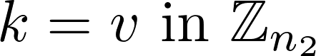

Now we can step out of and write a general formula for : 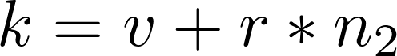 for any integer 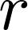
And FINALLY, we can use this formula for in the first formula for ()

We get
for any integer
ie
for any integer

Let’s do another example, without all the explanations. Make sure you can justify each step:

Example: find all values of that satisfy
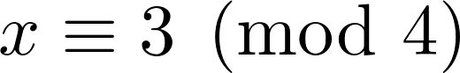
and
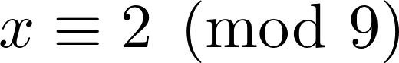

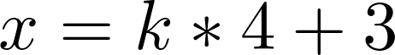
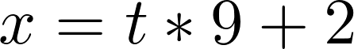

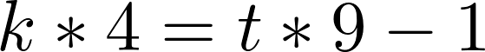

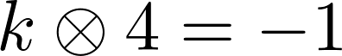 in 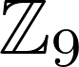

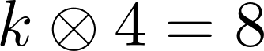 in (because 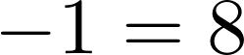 in )

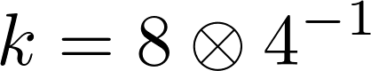 in

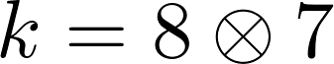 in

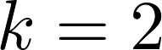 in

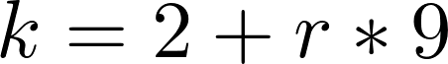 for any integer

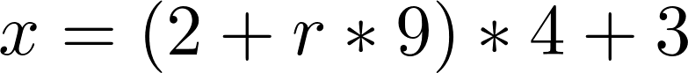 for any integer

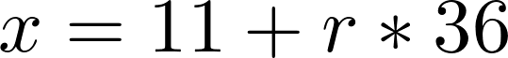 for any integer

Here’s another example:

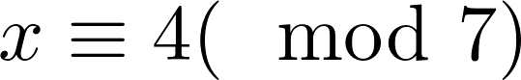

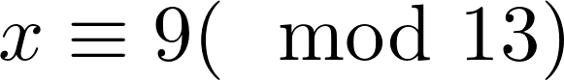

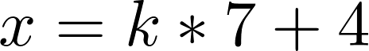
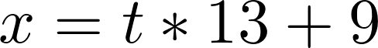

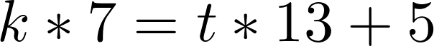

In 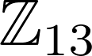 ...

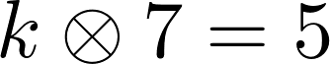

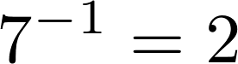 in (because 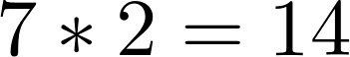)

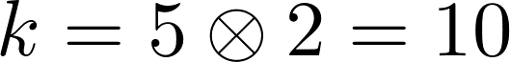 in

outside of , 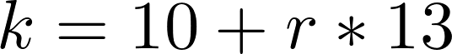

Yet Another Example (with some missing steps for you to fill in)

Find all solutions to 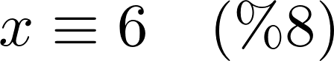
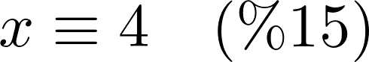

...

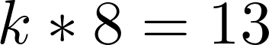 in 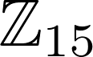

...
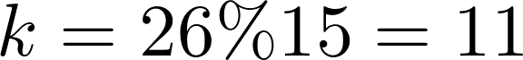 in

...

After all these examples you may be wondering if there is a way to shorten the computation. Well, yes there is.

Recall that when we did the general case, we ended up with

where 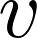 was a particular integer that we calculated, and 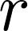 could be any integer.

But we know what is:

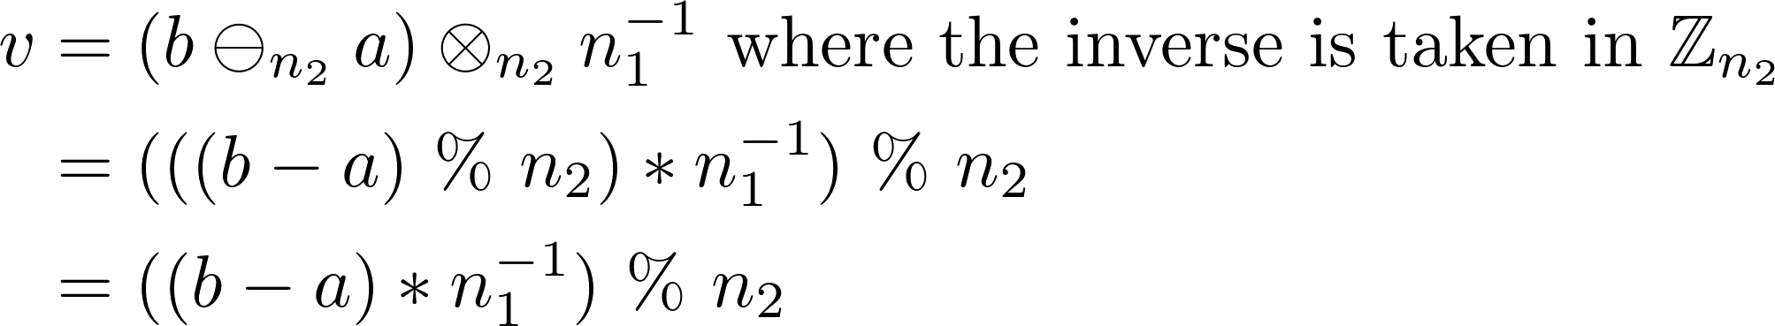

So we can write

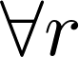

and now the only thing we actually have to compute is in . Once we know that, the rest is just simple arithmetic.
Now that we know we can check to see that all numbers that satisfy this are actually solutions to the original problem.

Consider 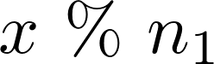 ... it’s pretty easy to see that the first and last terms just disappear when we apply the 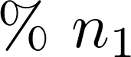 operation, so 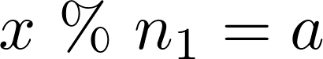

Now consider 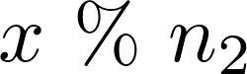 . This one is a little trickier

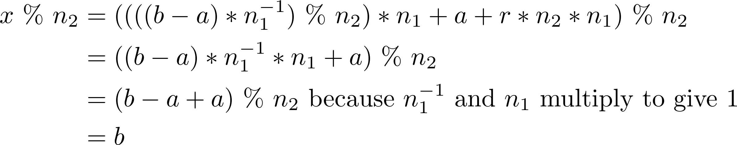

This gives us a starting point for a general form of the proof we did earlier that showed that there are no solutions to the sample problem other than the ones given by this method. Once again we can suppose that there is a solution that does not fit this pattern, and then show that it cannot satisfy both requirements. I’m not going to work through the details of that proof but it’s pretty straightforward.

I don’t know about you but I find it easier to remember the process for finding than to remember that final formula for . But if we were writing a program to solve the problem, using the final formula for would be the way to go.

Now we are ready to state the (Sunzi’s) Chinese Remainder Theorem:

If and are relatively prime and  and 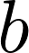 are any integers, then the equivalences

can be solved by any value of the form , where  is a particular constant and is any integer.

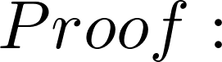 the procedure given above will compute the value of .

Furthermore, there is exactly one value of in the range 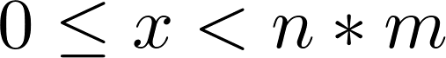 that satisfies these equivalences.

This innocent looking theorem is actually incredibly important. Much of modern digital security is based on doing modular arithmetic on very large integers. Sunzi’s Theorem lets us simplify many of these problems.

The Remainder Theorem actually generalizes:

If {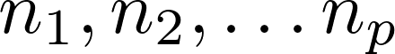} are all relatively prime and {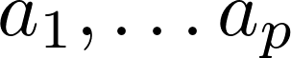} are any integers, the set of equivalences

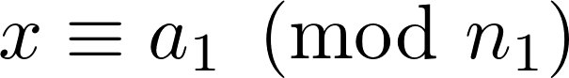
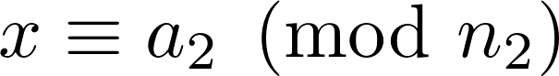
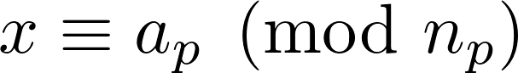

can be solved by any value of the form where is a particular constant and is any integer.

The value of is computed by extending the process we used above, in order to solve the situation with more than two equivalences.

It’s certainly reasonable to ask if the problem of finding to satisfy multiple equivalences can be solved when the modulus values are not relatively prime. The answer is ... sometimes.

Consider this problem:

Find all values of such that
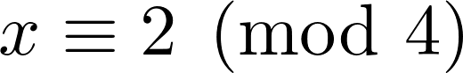
and
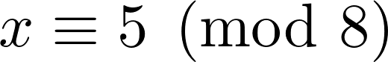

The values that satisfy the first requirement are all even since they are of the form 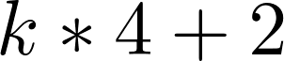

The values that satisfy the second requirement are all odd since they are of the form 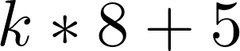

So there is no integer that satisfies both requirements.

But consider this problem:

Find all values of such that
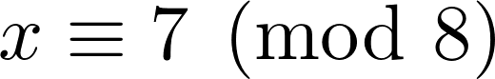
and
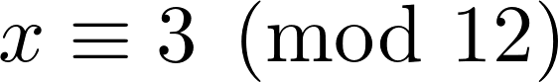

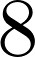 and 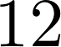 are not relatively prime, but these equivalence requirements can be met!
We can go through the same steps as our previous solutions to see what happens

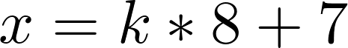
and
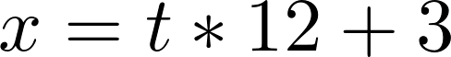
so

In 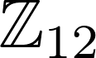 we get which gives
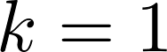 or 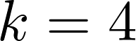 or 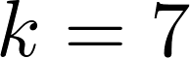 or 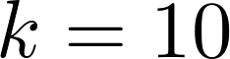

This gives 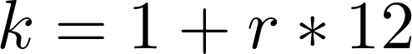 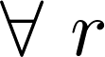 or
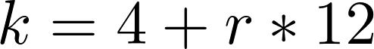 or
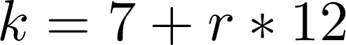 or

Plugging these back into we get

or
or
or

These are correct but we can simplify. It turns out that rather than just multiply and together (which is where we got the 96 value in the four options for x) we can use their least common multiple. Lcm(8,12) = 24 and our solutions reduce to:

which is exactly the same set of values as given by the 4 solutions just above.

The full analysis of multiple equivalences where the modulus values are not relatively prime is outside the scope of this course.
Cryptography

Now that we know lots of modular arithmetic we are ready to take a look at one of its most important applications: modern cryptography.

Imagine that Alice wants to send a message M to Bob. However, Eve can listen in on (or get a copy of) the message, and Alice and Bob don’t want Eve to know the message content. So Alice and Bob decide to use some sort of encryption method for their communication. They need to decide on an Encryption function E and a Decryption function D such that Alice can send X = E(M) and Bob can recover the original message by computing D(X ). The functions E and D have to be designed so that they are inverses: we need D to “undo” whatever E does.

A trivial example of E and D is
E: replace each letter of the message with the letter that follows it at some fixed distance r in the alphabet (for example, with r = 3, replace M by P, etc)
D: replace each letter of the encrypted message with the letter that precedes it at
distance r in the alphabet (replace P by M)

This form of substitution cypher is known as the Caesar Cypher because it was supposedly invented by Julius Caesar. In its simplest form it is very easy to break the code, but variations were developed that increased the security. For almost 2000 years the Caesar Cypher and variations of it have been used to protect confidential information – the famous Enigma cryptosystem that Turing and his team defeated during WWII was a very sophisticated multi-phase substitution cypher.

We can use modular arithmetic to create a simple substitution cypher: Alice and Bob can decide to work in 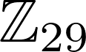 (chosen since 29 is prime and > 26) and agree on a secret multiplier such as 11. When Alice wants to transmit a message she converts each letter to an integer (A = 1, B = 2 etc), multiplies each integer by the secret multiplier 11, and sends the result (so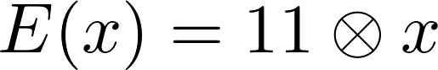 in ). Bob decodes by multiplying the integers he receives by 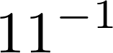, which happens to be 8 in

As long as Eve doesn’t know that the secret multiplier is 11, she has a bit of a problem. Unfortunately for Alice and Bob, Eve can try all the possible values and see which one produces a readable message, so this isn’t very secure. She could also apply simple statistical analysis to the encoded message. However it’s a very good starting point for our discussion of truly secure cryptography.

If Alice and Bob can meet in a secure location to decide on E and D, there are options that are extremely secure (for more information, search “one-time pads” for example). But if Alice and Bob can only communicate over the channel that Eve is listening to, they have a problem: how can they agree on E and D without Eve knowing D?

The first suggestions that modular arithmetic might provide a solution started to appear in the 1970’s. You might want to look up Diffie and Hellman, for example. However the first popular and (somewhat) practical solution was made public in 1977/1978 by three MIT researchers named Rivest, Shamir and Adleman. This method is now called RSA Cryptography. There are many variants – we will focus on the one described in our textbook. It turns out that the RSA cryptography method had been discovered several years earlier by a British mathematician named Clifford Cocks, but his work was classified secret by the British government and not revealed until 1997.

The basic idea is that Bob designs the functions that will be used when Alice sends him a message. Because these are Bob’s functions, we call them 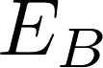 and 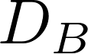 (If they want two-way communications, Alice will have to design functions too). Bob creates the and functions in private. He publishes in a public place where everyone can see it (including Eve) but he keeps very secret. Now Alice (or anyone) who wishes to send an encrypted message to Bob uses to encode it. Since Bob is the only person who knows , Eve cannot decrypt the message.

If Alice wants to receive secure messages she needs to create her own functions (we can call them  and ). Like Bob, she publishes but keeps secret.

But how is this going to work? How can we find an encryption function with the property that even if Eve knows exactly how works, she cannot figure out ?

In all of the examples we have looked at, it was extremely easy to figure out the decryption method if we knew the encryption method.

This was the problem that Rivest, Shamir and Adleman solved … and they did it using exponentiation in modular arithmetic. We’ll look at their method next.

